Question 2 :
Hive
Please find the customer data set.
cust id
firstname
lastname
age
Profession

1) Write a program to find the count of customers for each profession.

ANSWER

hive> select profession,count(custno) as cnt from customer group by profession order by cnt;

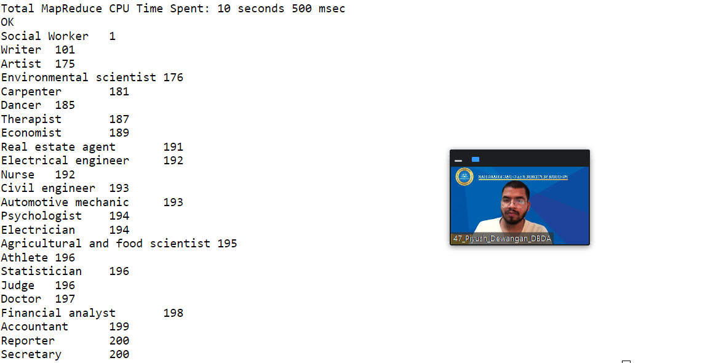

HIVE : 2) Write a program to find the top 10 products sales wise

ANSWER

hive> select product, sum(amount) as cnt from txnrecords group by product order by cnt desc limit 10;

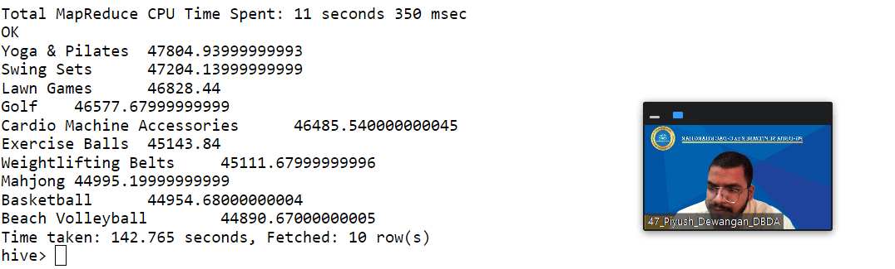

3) Write a program to create partiioned table on category

ANSWER

create table txnrecsbycat2(txnno INT, txndate STRING, custno INT, amount DOUBLE,
product STRING, city STRING, state STRING, spendby STRING)
partitioned by (category STRING)
row format delimited
fields terminated by ','
stored as textfile;

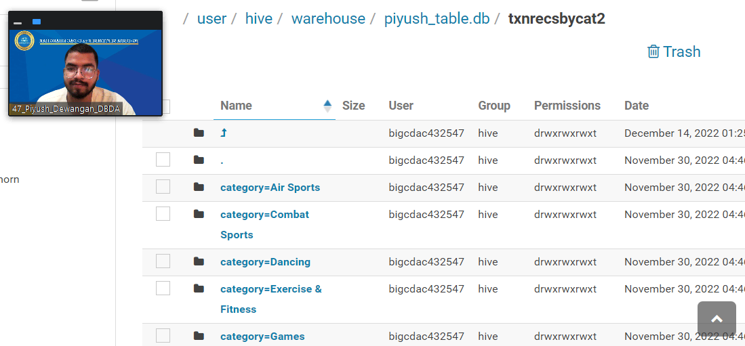

QUESTION 3 [15 marks]
PySpark
Please find the AIRLINES data set
Year
Quarter
Average revenue per seat
Total number of booked seats
1). What was the highest number of people travelled in which
year?

ANSWER

df1 = spark.sql("select Year, sum(Total_booked_seat) as total from airlines group by year order by total desc
limit 1")

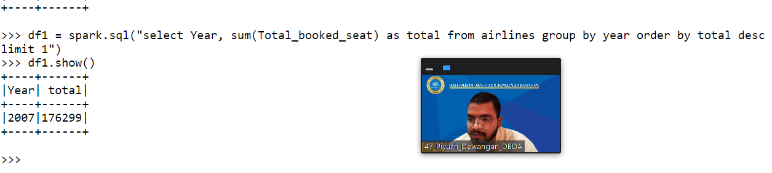

2). Identifying the highest revenue generation for which year ?

ANSWER

df2 = spark.sql("select Year, sum(Avg_revenue) as total from airlines group by year order by total desc limit 1")

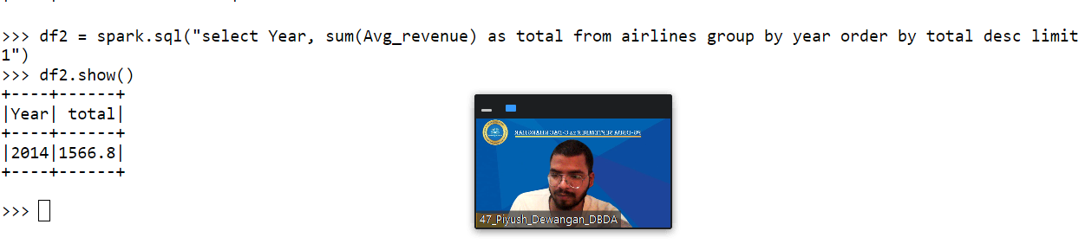

3). Identifying the highest revenue generation for which year and quarter (Common group)

ANSWER

df3 = spark.sql(“select year, quarter, sum(Avg_revenue) as total from airlines group by year, quarter order by total desc limit 1”)

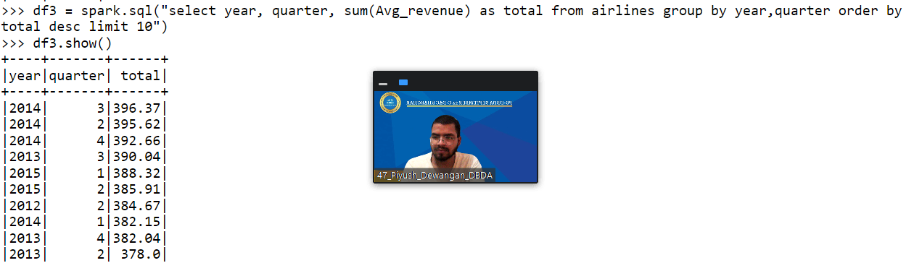

Que 1 : MAP-Reduce (All Time High)
ANSWER :

import java.io.IOException;
import java.util.StringTokenizer;
import org.apache.hadoop.conf.Configuration;
import org.apache.hadoop.fs.Path;
import org.apache.hadoop.io.IntWritable;
import org.apache.hadoop.io.LongWritable;
import org.apache.hadoop.io.Text;
import org.apache.hadoop.mapreduce.Job;
import org.apache.hadoop.mapreduce.Mapper;
import org.apache.hadoop.mapreduce.Reducer;
import org.apache.hadoop.mapreduce.lib.input.FileInputFormat;
import org.apache.hadoop.mapreduce.lib.output.FileOutputFormat;

public class AllTimeHigh {

public static class MapClass extends Mapper<LongWritable,Text,Text,DoubleWritable>
{
public void map(LongWritable key, Text value, Context context)
{
try{
String[] str = value.toString().split(",");
double high = Double.parseDouble(str[4]);
context.write(new Text(str[1]),new DoubleWritable(high));
}
catch(Exception e)
{
System.out.println(e.getMessage());
}
}
}

public static class ReduceClass extends Reducer<Text,DoubleWritable,Text,DoubleWritable>
{
private DoubleWritable result = new DoubleWritable();

public void reduce(Text key, Iterable<DoubleWritable> values,Context context) throws IOException, InterruptedException {
double max = 0.00;

for (DoubleWritable val : values)
{
if (val.get() > max) {
max = val.get();
}
}

result.set(max);
context.write(key, result);
//context.write(key, new LongWritable(sum));

}
}
public static void main(String[] args) throws Exception {
Configuration conf = new Configuration();
conf.set("mapreduce.output.textoutputformat.separator",",");
//conf.set("name", "value")
conf.set("mapreduce.input.fileinputformat.split.maxsize", "28311552");
Job job = Job.getInstance(conf, "All Time High Price for each stock");
job.setJarByClass(AllTimeHigh.class);
job.setMapperClass(MapClass.class);
job.setCombinerClass(ReduceClass.class);
job.setReducerClass(ReduceClass.class);
job.setNumReduceTasks(1);
job.setOutputKeyClass(Text.class);
job.setOutputValueClass(DoubleWritable.class);
FileInputFormat.addInputPath(job, new Path(args[0]));
FileOutputFormat.setOutputPath(job, new Path(args[1]));
System.exit(job.waitForCompletion(true) ? 0 : 1);
}
}

